Paper Title (use style: paper title)

Author(First Name Surname)^{1,}, Author(First Name Surname)²
¹ Department , Affiliation, Country
E-mail address: XXX@mail.XXXX

² Department ,Affiliation, Country
E-mail address: XXX@mail.XXXX
Abstract
The abstract should be a summary of your presentation and included the keywords. Please avoid scientific or engineering symbols, acronyms and bullets. The submission should be typed single-spaced in 12-point type Times New Roman in Microsoft Word file (*.doc/*docx). The length should be within 800 words in 2 pages.

Full Paper
The full paper is not required for participating in the conference. However, a full paper submission will be required if you would like us to recommend your paper to our co-journals after the conference.

1. Introduction
The submission should be typed single-spaced in 12-point type Times New Roman in Microsoft Word file (*.doc/*docx). The full manuscript is limited to 15 single-spaced pages, including abstract, references, tables/charts/ pictures and keywords.

  - Formula and Equation
In this sample, the following equations are presented as illustration.
$\int{ F(r,ϕ)} \text{dr} dϕ=[{σr}_{2} (2μ_{0})]$ (1)
where t = 0, . . . , T, and b is a number greater than 1.
It should be noted that all easily confused characters and symbols, upper and lower case letters, as well as block and italicized lettering should be noticed to the proceedings editor

  - Figures, Tables and Picture
Figures and tables should be placed in suitable spaces and avoid placing them in the middle of columns. The tables should also be numbered like Table 1, 2, 3…etc and same as the figure. Figure captions should be centered below the figures; table captions should be centered above. Figures should be supplied in either vector art formats (Illustrator, EPS, WMF, FreeHand, CorelDraw, PowerPoint, Excel, etc.) or bitmap formats (Photoshop, TIFF, GIF, JPEG, etc.). Bitmap images should be of 300 dpi resolution at least. Pictures should be supplied electronic image file, original files of 300dpi or more and should be indicated the file name and an ordinal number of picture.

Table 1. The sample
Item 1 | Number 1 | Number 2
Item 2 | Number 3 | Number 4
Item 3 | Number 5 | Number 6

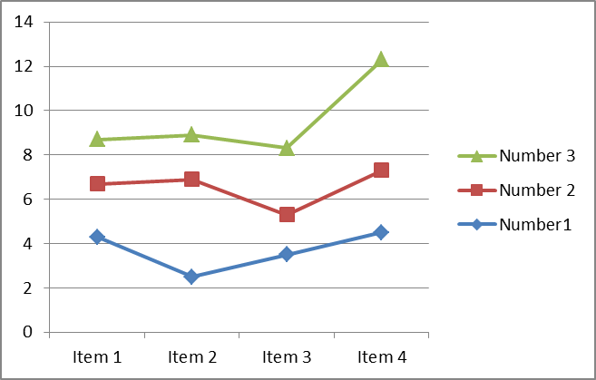
Figure 1. The sample
Reference
Papers should follow the style recommended by the American Psychological Associations (APA) Publication Manual (please visit http://www.apastyle.org/learn/quick-guide-on-references.aspx ).

